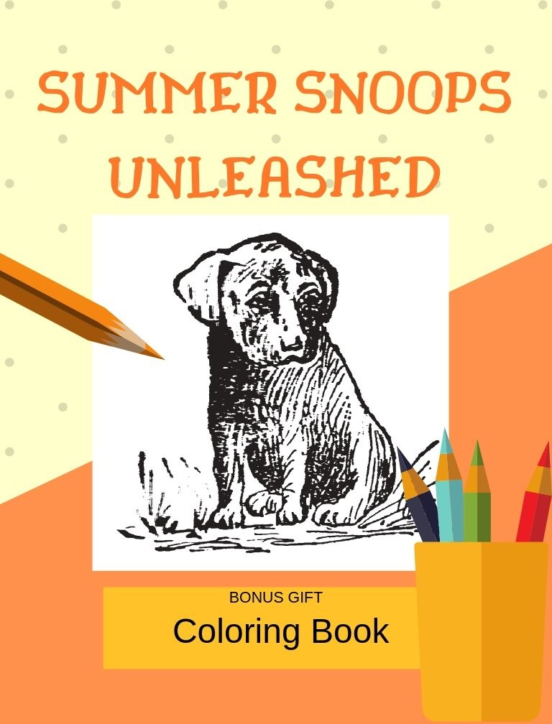

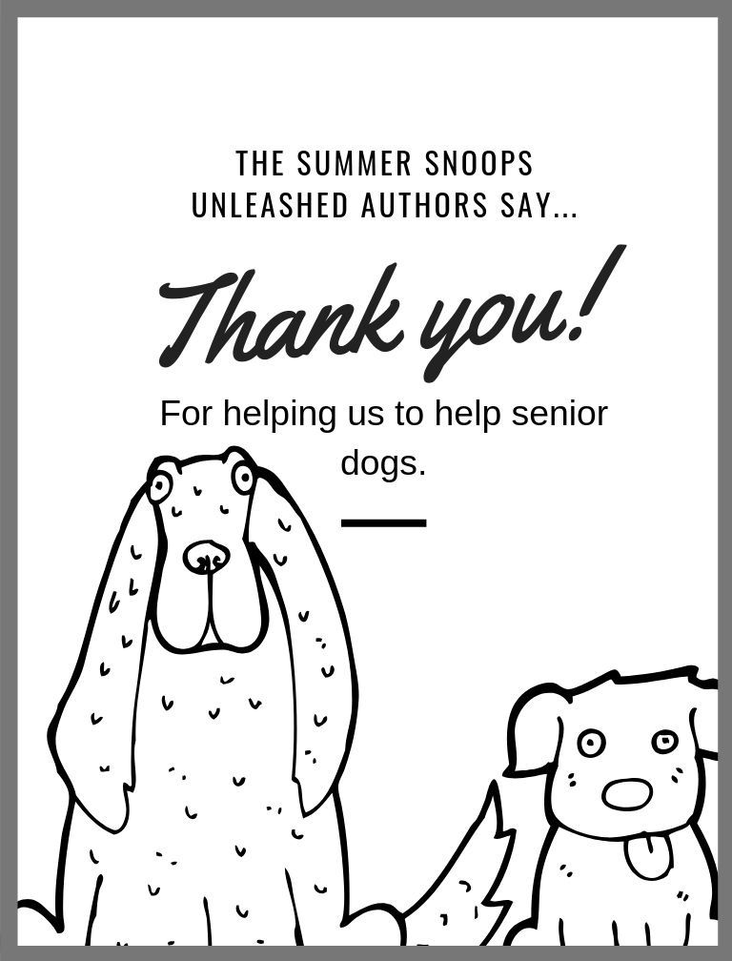

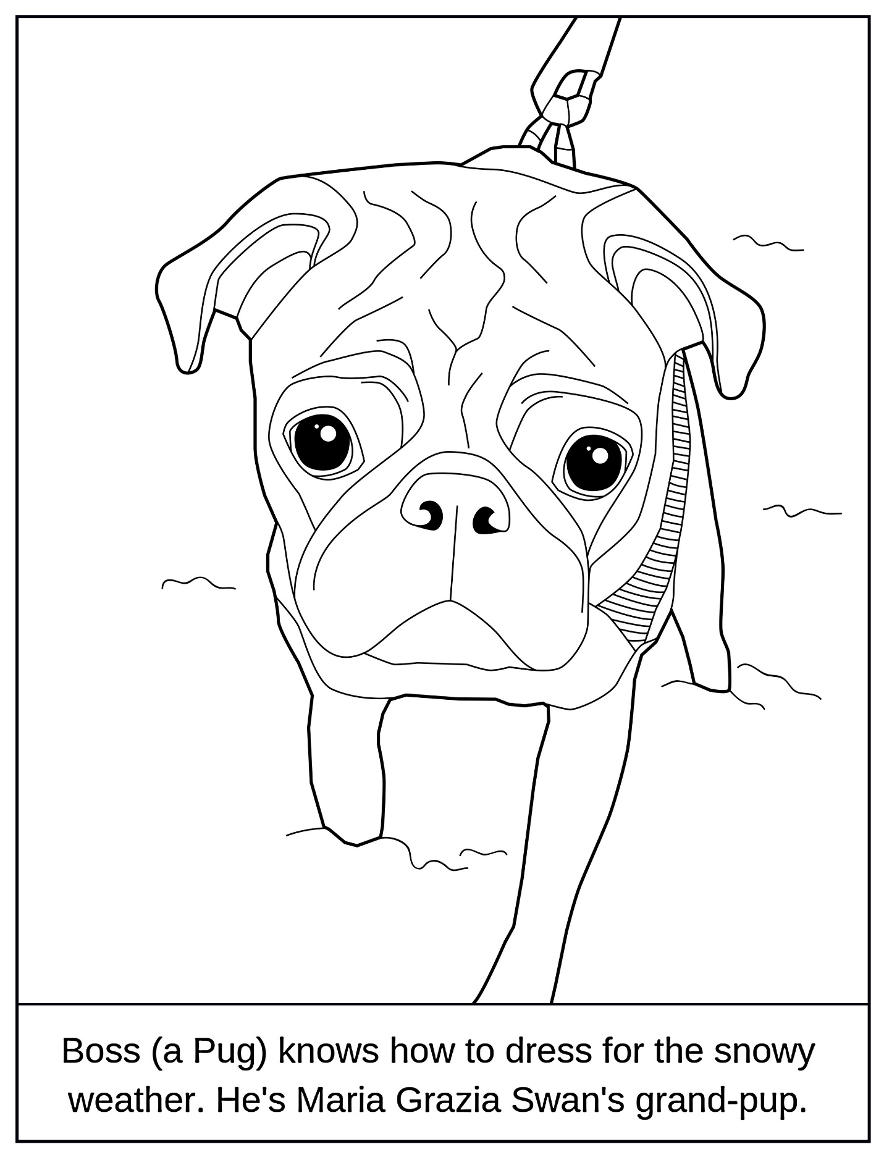

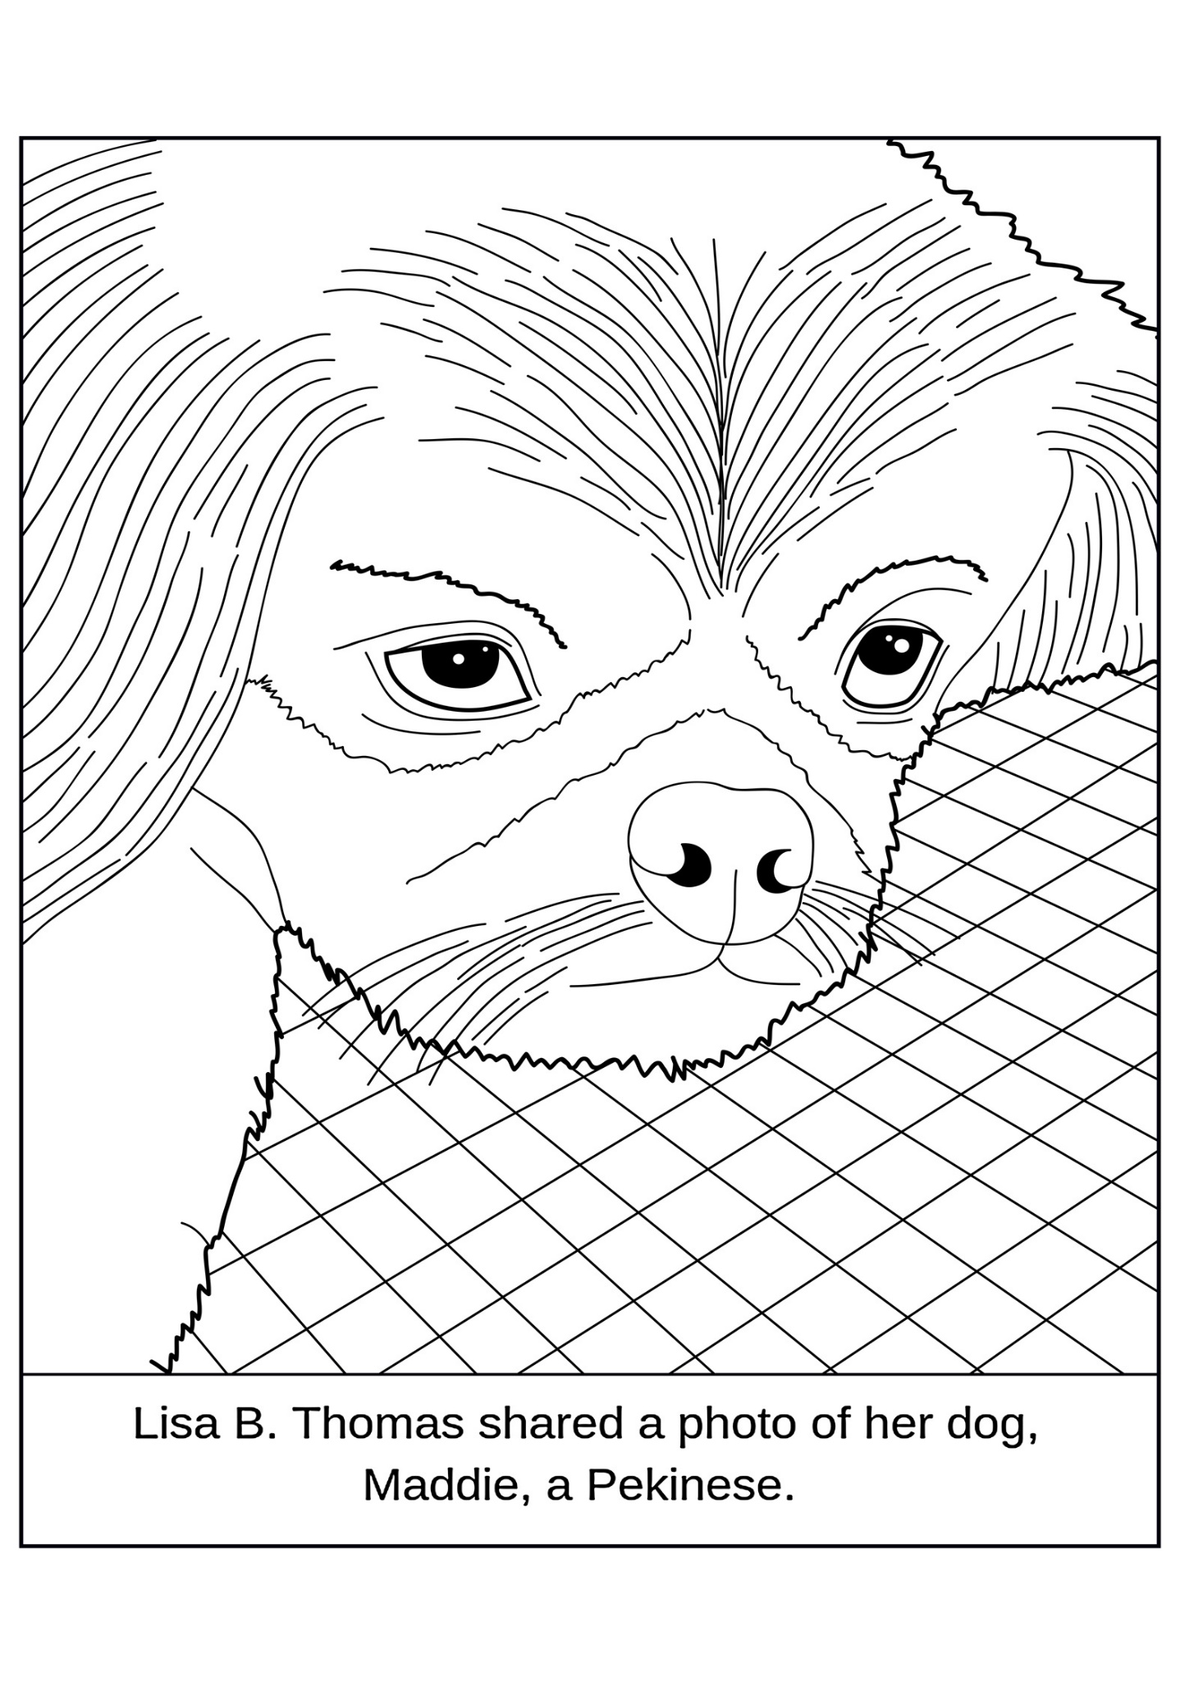

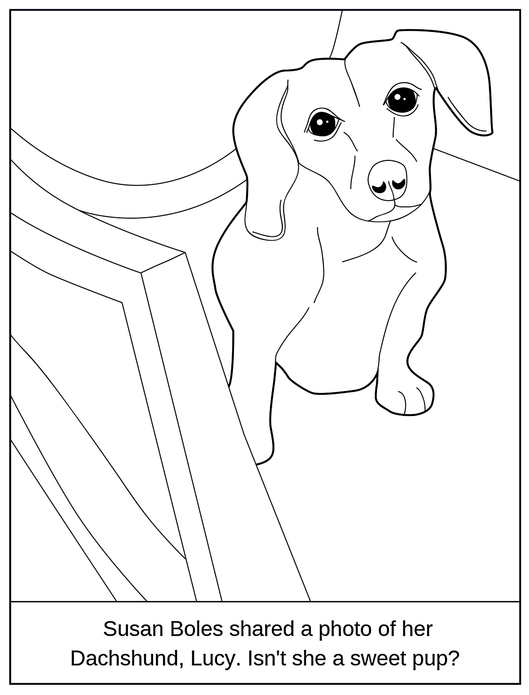

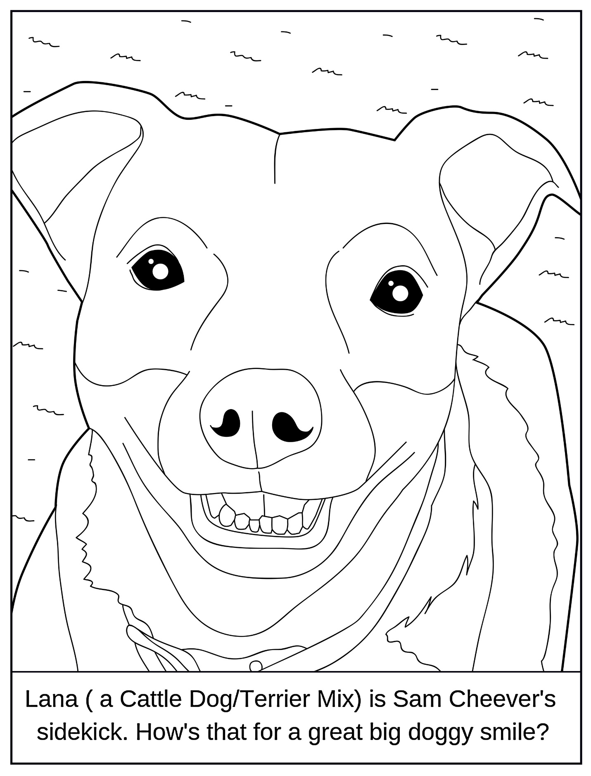

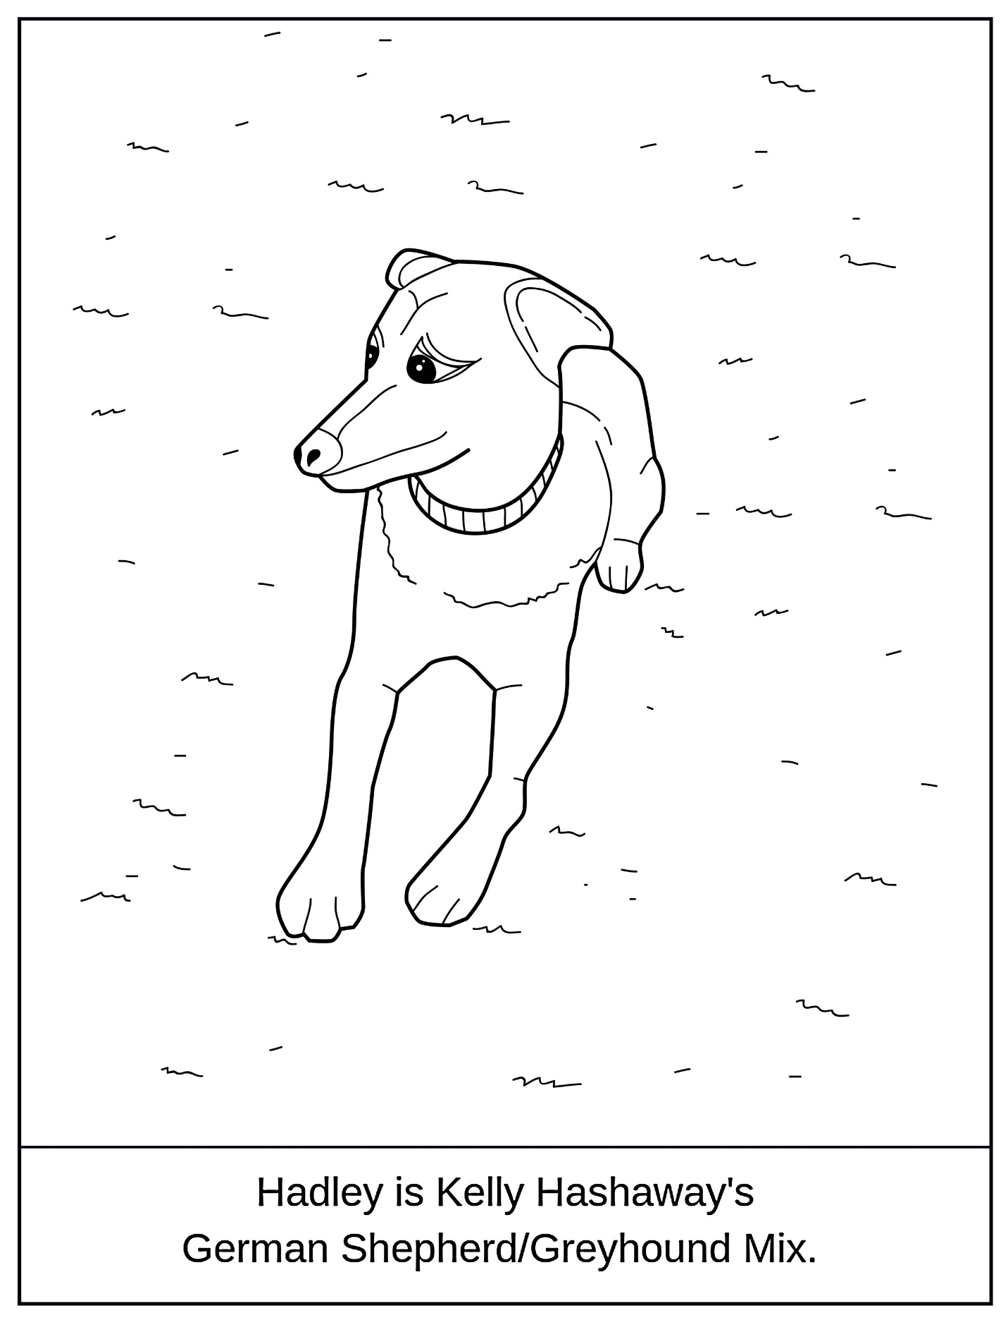
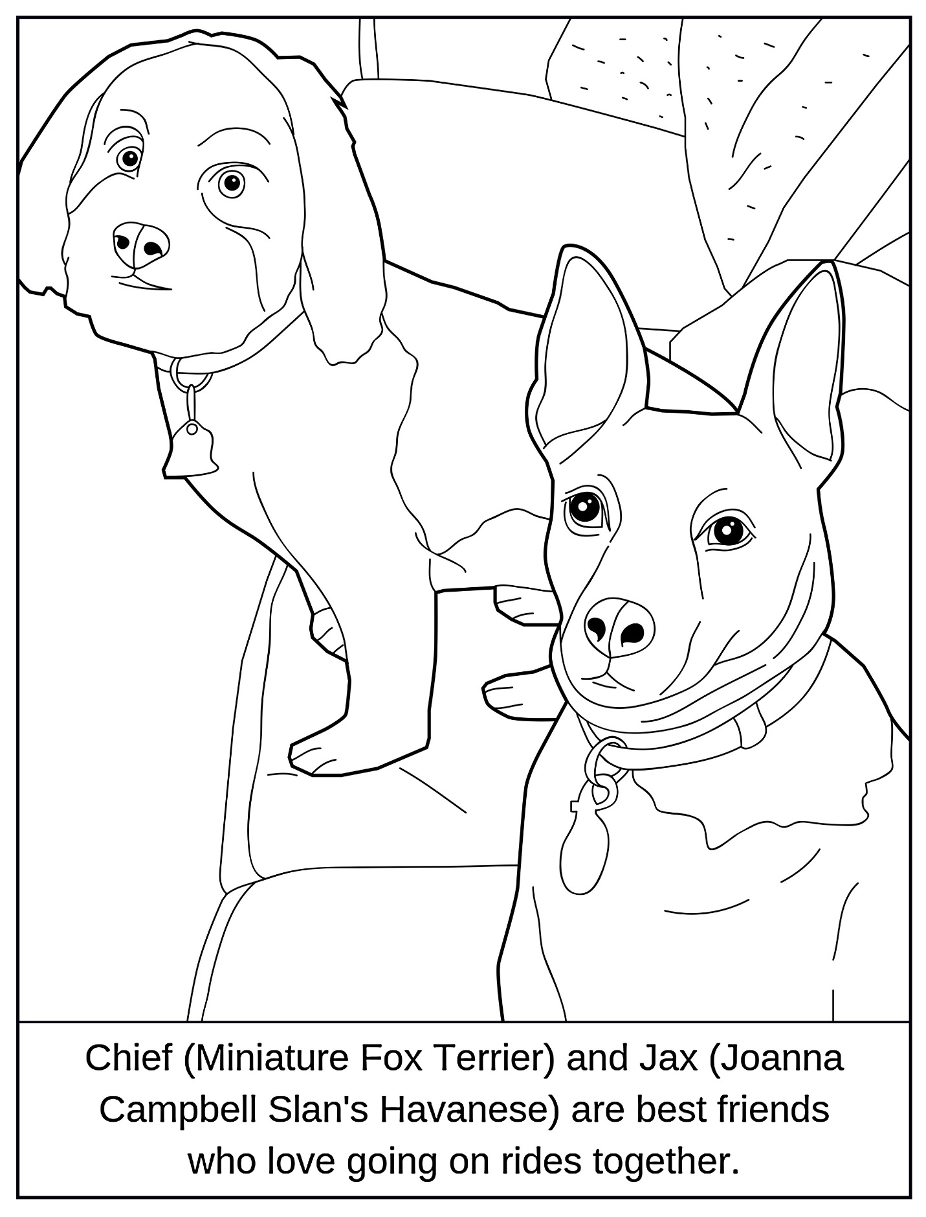

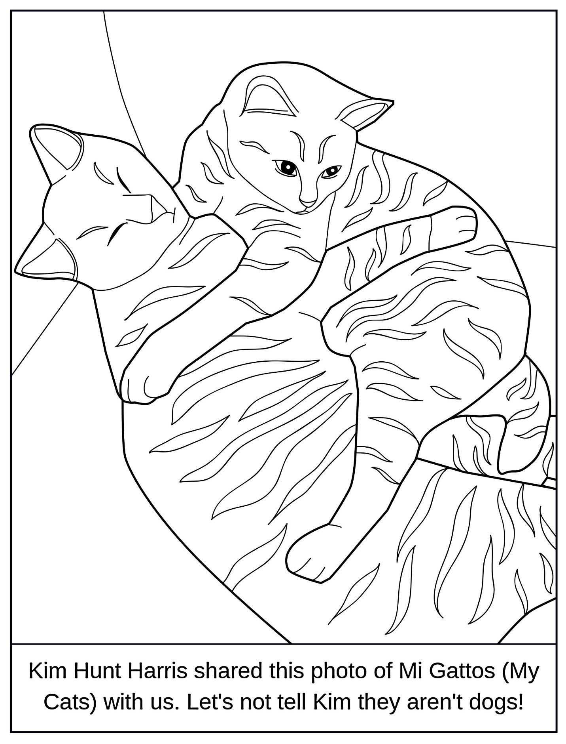

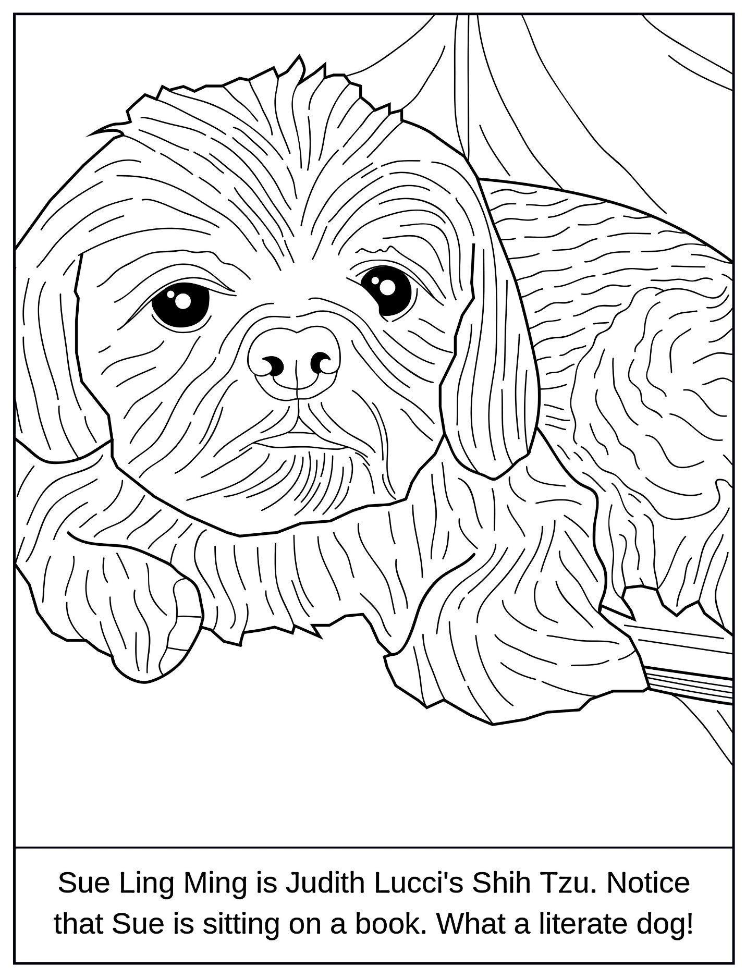

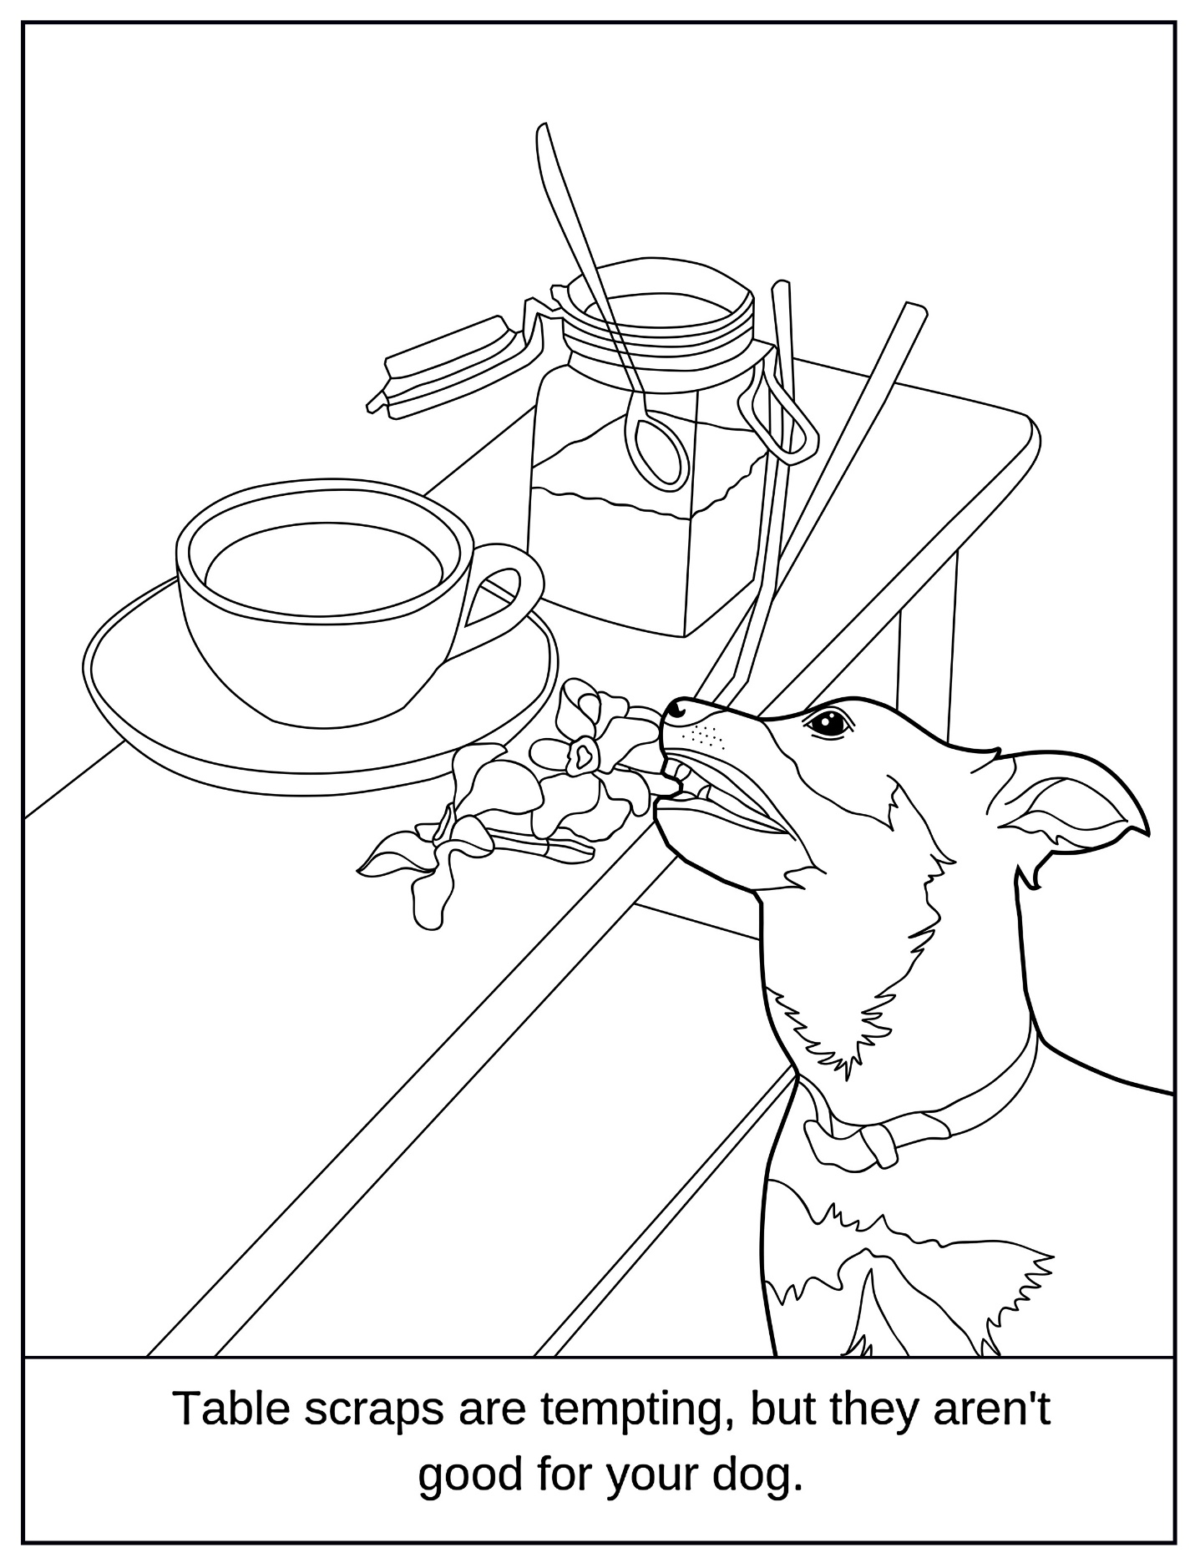

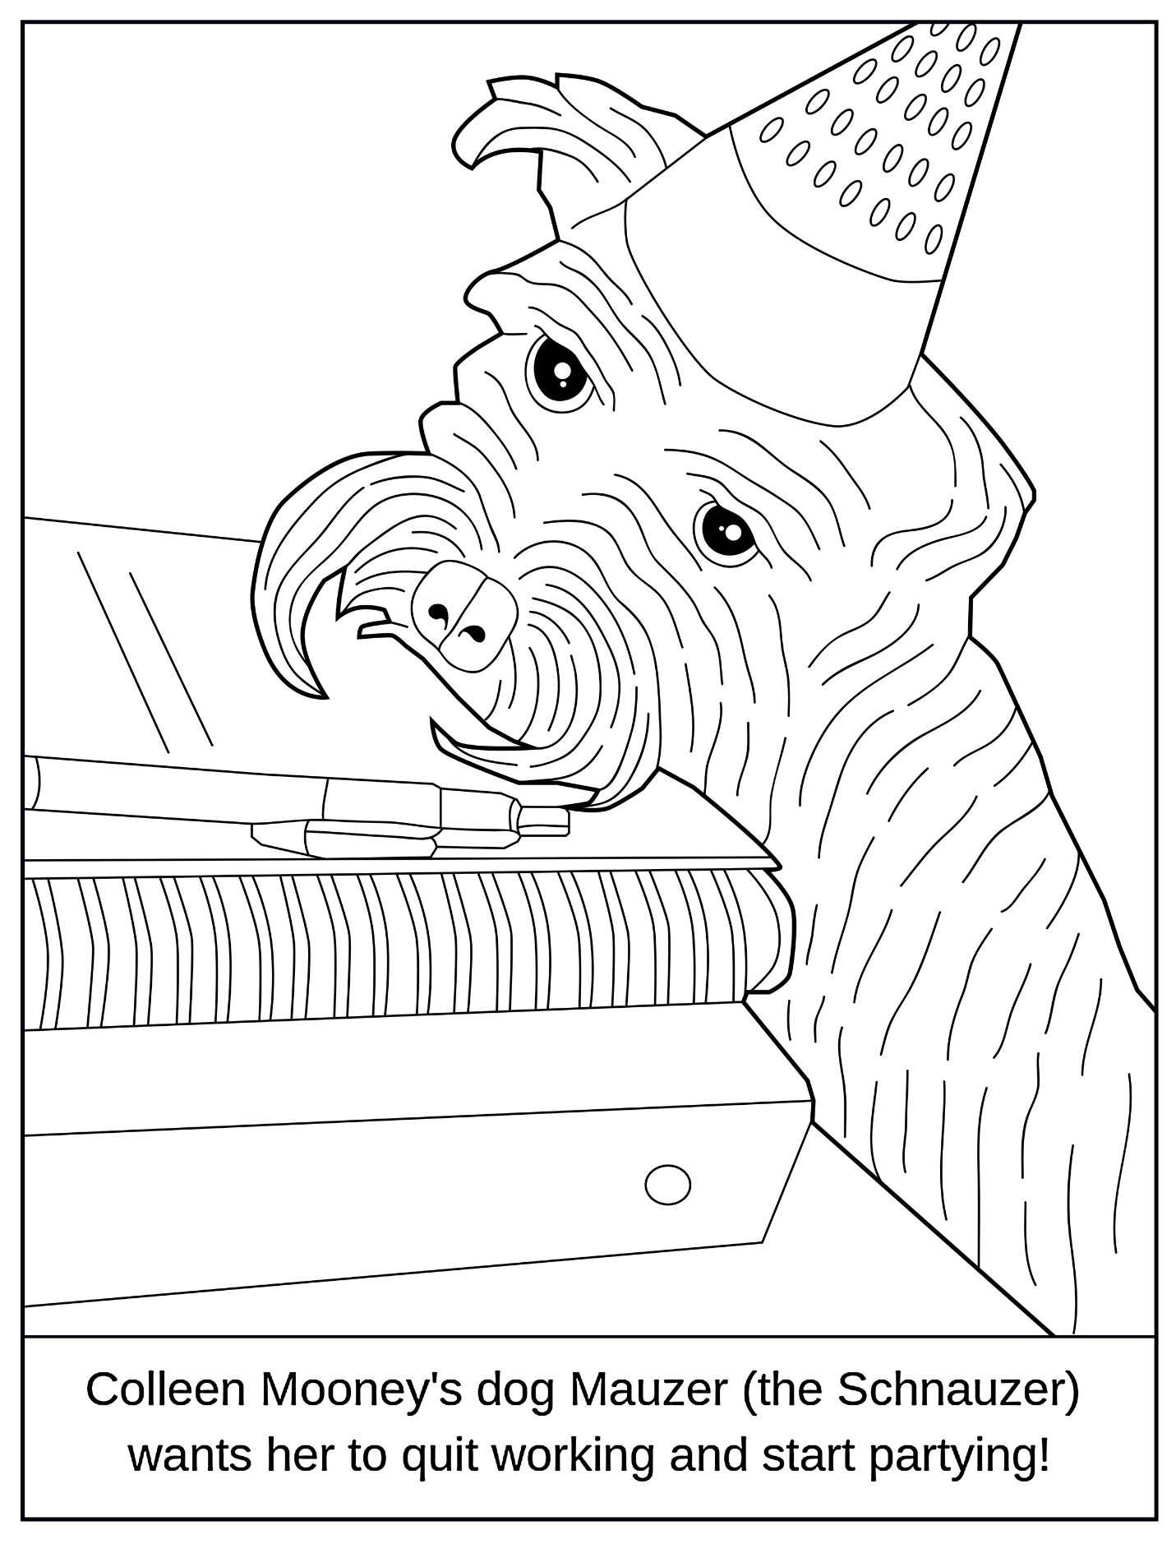

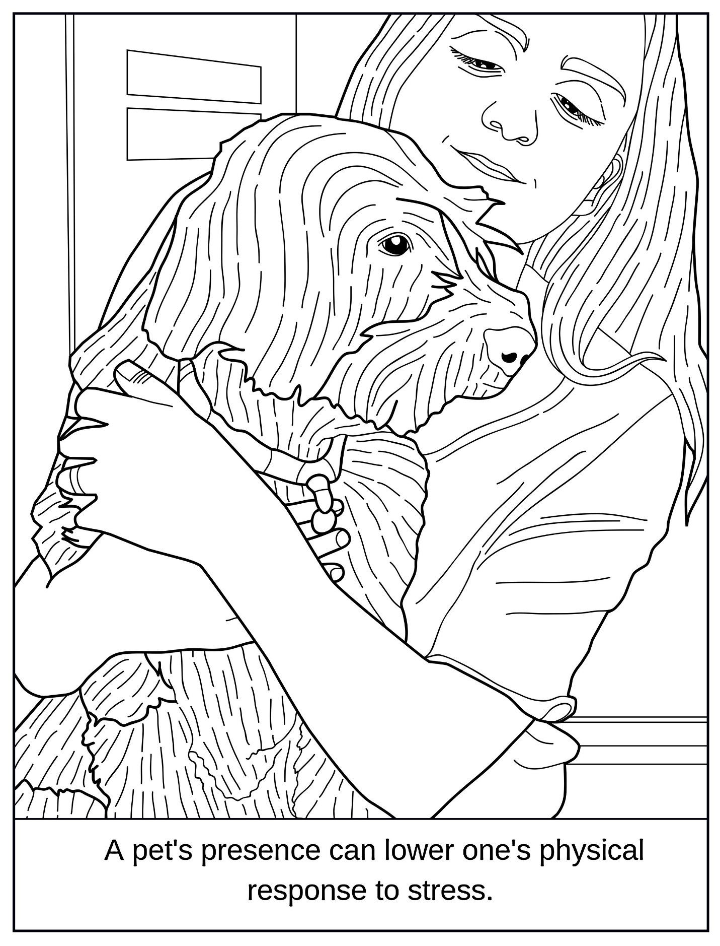

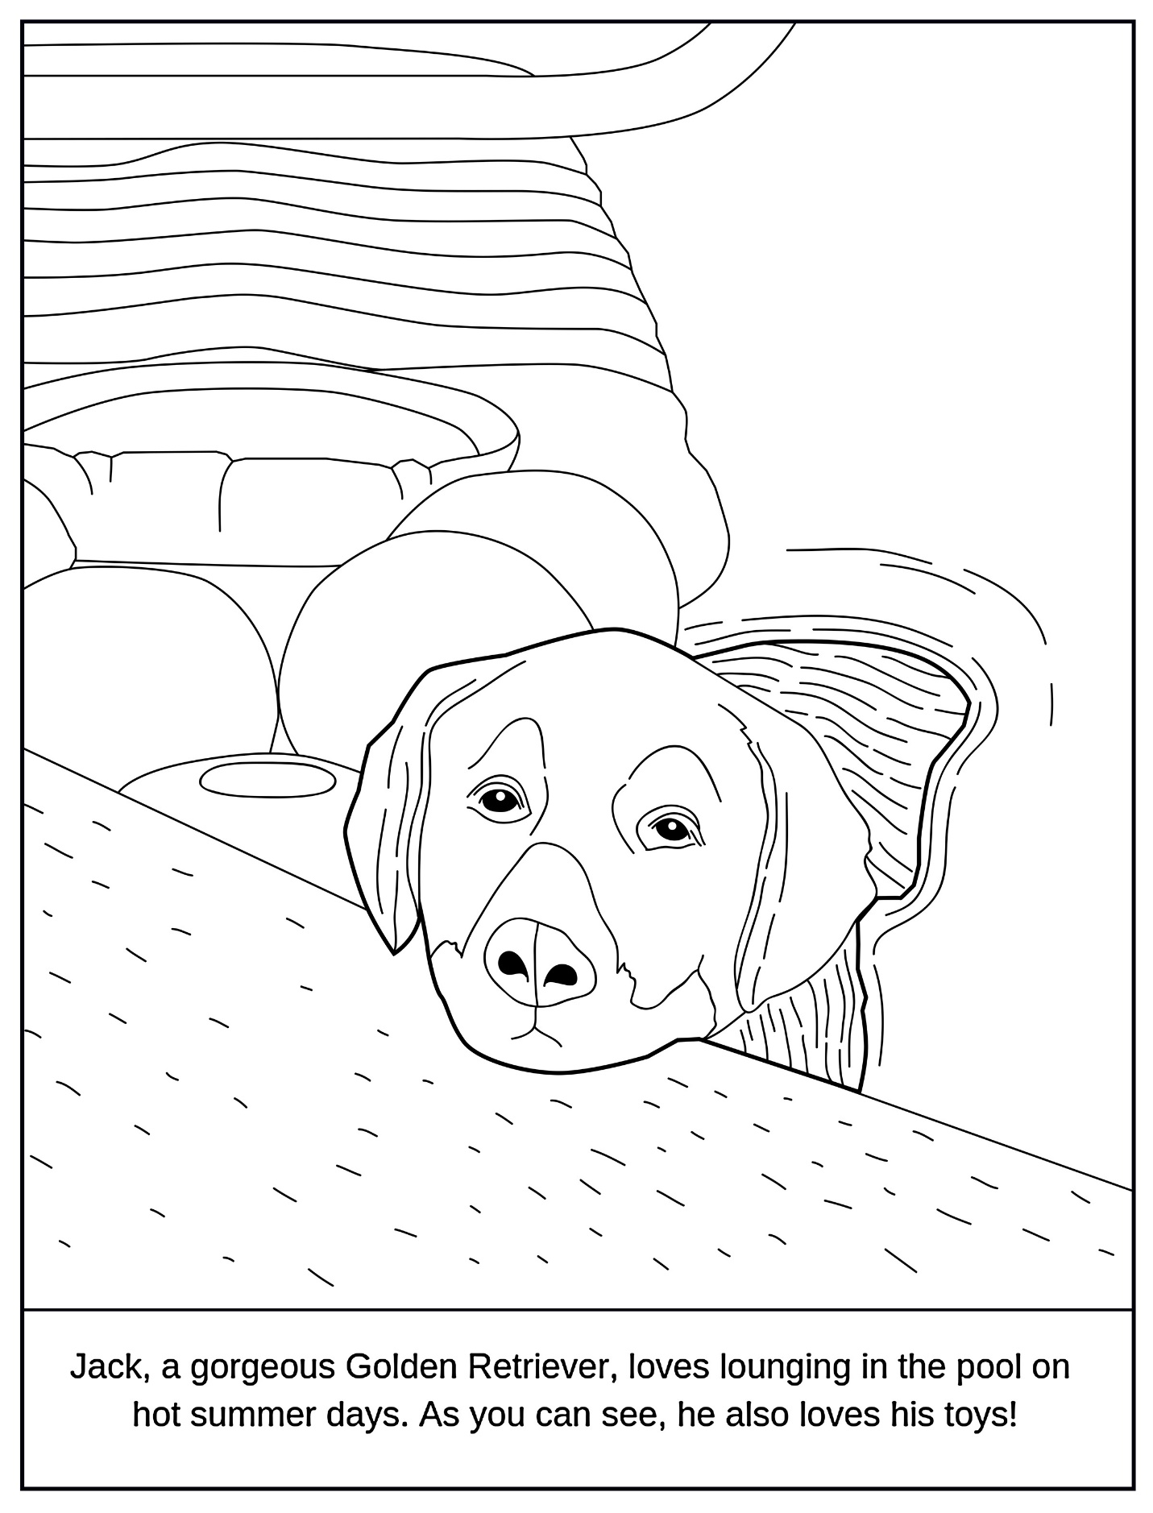

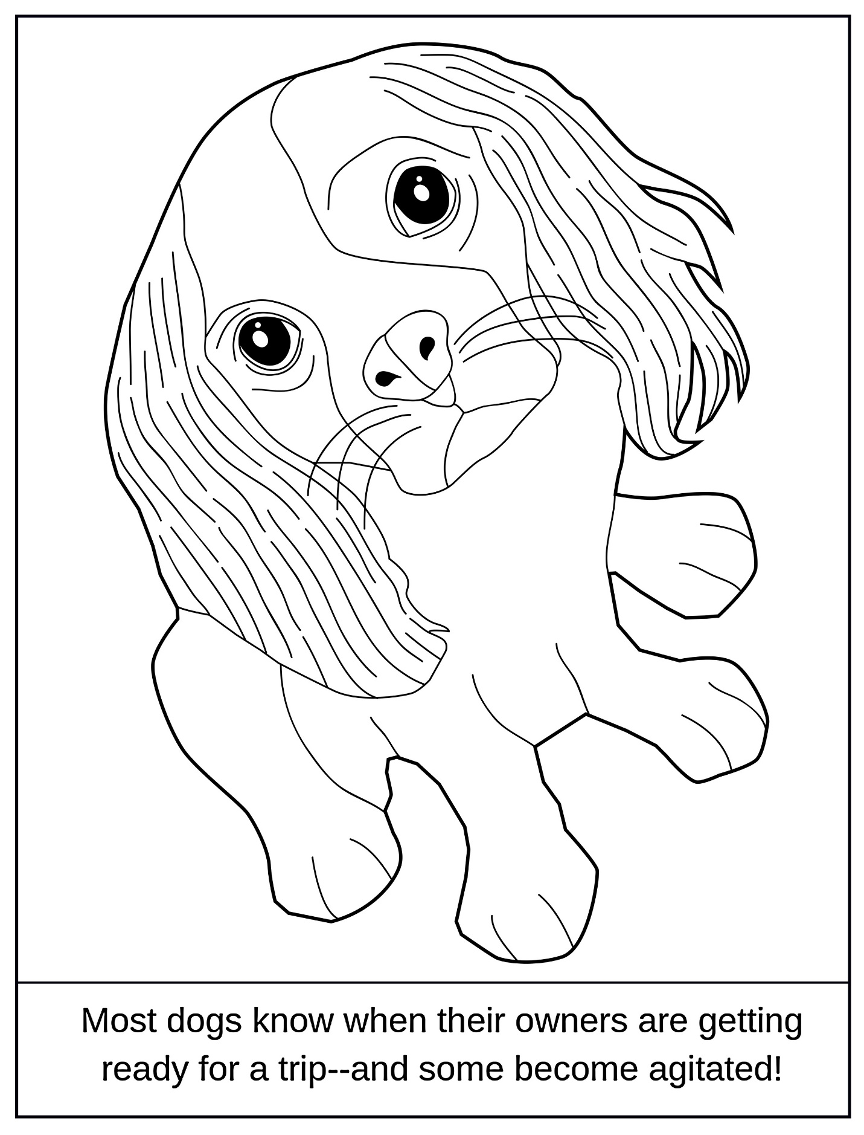

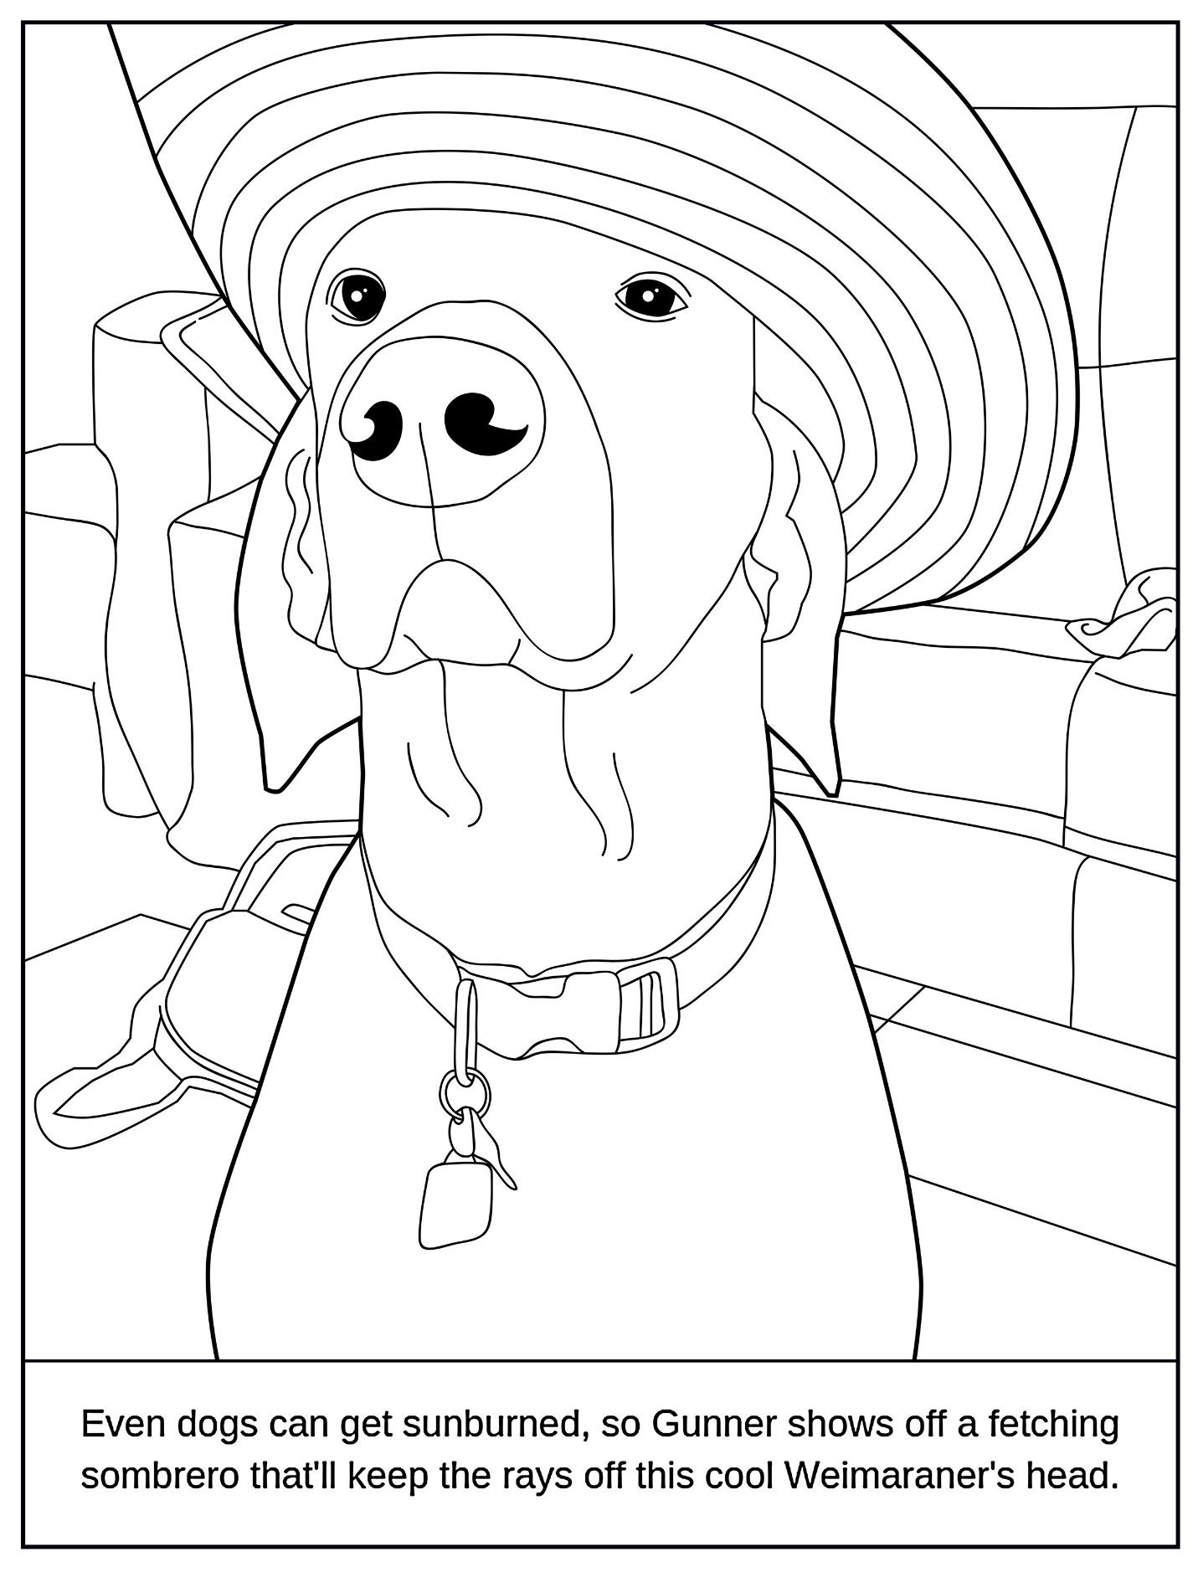

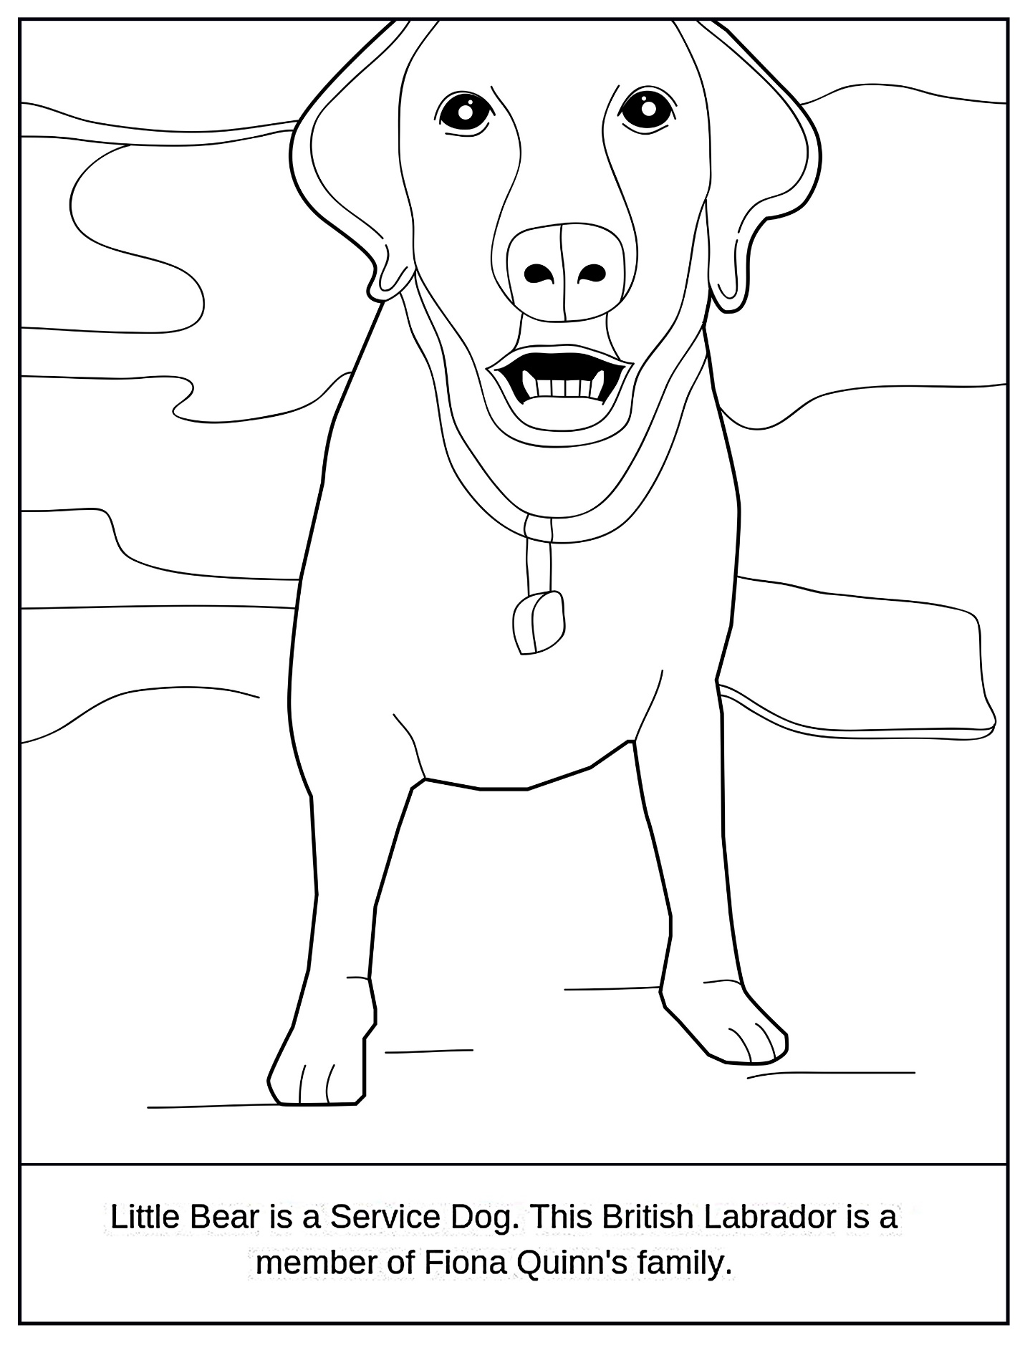

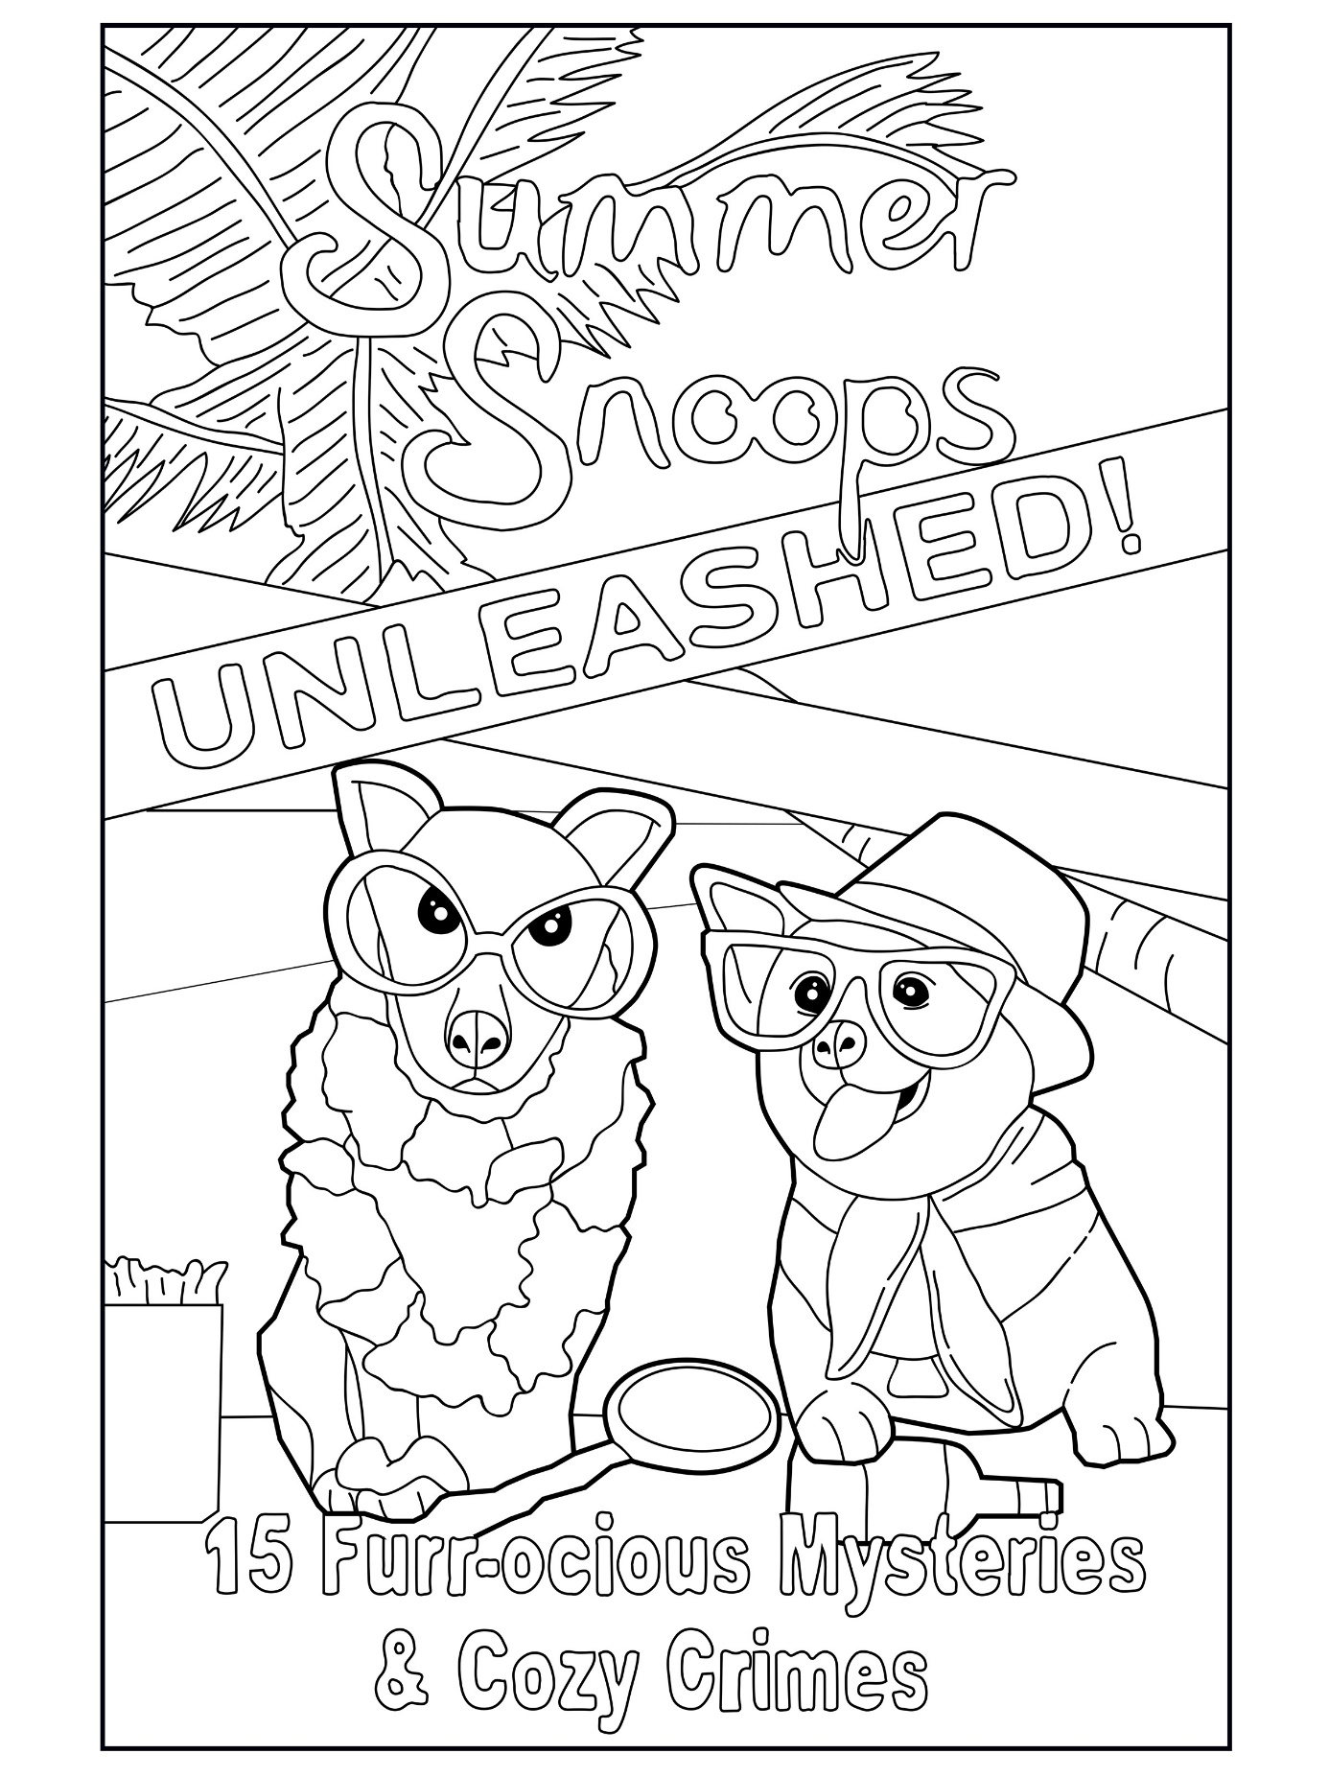

MEET THE SUMMER SNOOPS UNLEASHED AUTHORS

Judith Lucci loves animals. She's the proud pet owner of four dogs and one cat who live well in their FURR-EVER Home. She's also a USA Today and Wall Street Journal Best Selling author who writes cozy mysteries, medical thrillers and psychological fiction. Judith's Artzy Chicks Cozy Mystery Series has lots of pets who live at the Art Gallery. Some are well-behaved, but ... well, some just aren't!

Maria Grazia Swan wishes all pets could live forever, or at least as long as their owners. Since that's still a wish, she fills her time working with rescue shelters and other deserving pets waiting for their furr-ever home. She writes books about…you guessed it…pets, rescue shelters, and good and bad people. And in every book, the bad people get their just punishment. Wishing you all a loving fur baby in your life.
Kim Hunt Harris spent ten years working as a dog groomer because, even when they're getting bathed and brushed, dogs are often more pleasant to be around than people. Even now that she doesn't do that job full-time, animals are a big part of her day. The owner of three dogs and two cats, Kim is a USA Today and Wall Street Journal Bestselling author who will always have a pet in her cozy mysteries.

Colleen Mooney has a breed rescue she runs called Louisiana Schnauzer rescue in New Orleans. She’s been doing this for almost 15 years and placed over 375 Schnauzers. She is also the founding chapter president of Sisters in Crime New Orleans. She has served on the board for a Humane Society doing fundraising events. I continue to do fundraising for Schnauzer Rescue, and we have a big Oktoberfest parade here in New Orleans featuring our rescue pets! I have always had four Schnauzers of my own, which is why I had to get in rescue to help more. No matter how long our pets are with us, it’s never long enough so make the best out of every day you have with them.

Anna Celeste Burke is a USA Today & Wall Street Journal bestselling author who lives in the desert near Palm Springs with her beloved husband and loudmouthed Siamese cat. A retired professor who once worked as a Disney chef, you'll find her snooping into life's mysteries with fun, fiction, and food!

Kelly Hashway is a USA Today bestselling author who loves spending time with her rescue dog, Hadley. Kelly loves a good mystery, and as both an author and editor, she spends her time between the pages of great books.

Fiona Quinn is a four-time USA Today bestselling author, a Kindle Scout winner, and has been listed as an Amazon Top 100 author in: romantic suspense; mystery, thriller, and suspense; mysteries, science fiction, fantasy, and horror.

Lisa B. Thomas writes mysteries with heart and humor, including the Maycroft Mysteries, the Killer Shots Mysteries, and the Beachside Books Magical Cozy Mysteries (co-authored with Paula Lester). When she's not plotting murders, she's enjoying family and her recently rescued Pekingese.

USA Today and Wall Street Journal Bestselling Author Sam Cheever writes mystery and suspense, creating stories that draw you in and keep you eagerly turning pages. Known for writing great characters, snappy dialogue, and unique and exhilarating stories, Sam is the award-winning author of 80+ books.

Susan Boles is a USA Today and Wall Street Journal Bestselling Author who lives in Mississippi with her rescue mini Dachshund and rescue cat of no particular breed. You’ll find her writing mysteries centered around small southern towns with lots of great characters.

Chelsea Thomas is technically two people, married writing team Chelsea and Matthew Thomas. Chelsea and Matt write the “Apple Orchard Cozy Mystery Series.” They also work as screenwriters, and recently completed a move from Los Angeles to New York.

Emily Selby is a Wall Street Journal Bestselling Author who lives between France and New Zealand with her husband, daughter, and a multilingual rescue cat. She loves writing and reading cozy mysteries with a sprinkle of romance, full of quirky characters and set in charming little towns.

Ava Mallory is a multi-genre USA Today and Wall Street Journal Bestselling Author of what she affectionately calls Fiction with Heart. When not dreaming up stories full of twists and turns, she's spinning heartwarming tales of love, laughter, and a healthy dose of mystery.

Joanna Campbell Slan can’t imagine life without a dog. Seriously? No way. Joanna’s a New York Times Bestselling Contributor to five of the Chicken Soup for the Soul books, a National Bestselling Author, and an Award-Winning Author who has appeared on Amazon’s Top 100 Mystery Author list. Her best friend is her Havanese pup, Jax, who is napping as she writes this.

